**ASSIGNMENT NO-09**

**Problem Statement:-** Deploy a project from github to EC2.

**Steps:-**

**EC2 Creation:-**

1. Login to AWS account and go to search option and search EC2.At the left sight in the “instances” click instances .Click on “Launch instances” and enter the name(ex-manec1) ,click hardware “Ubuntu”, check the hardware if it is 64-bit or not and then check if the software is t2.micro.

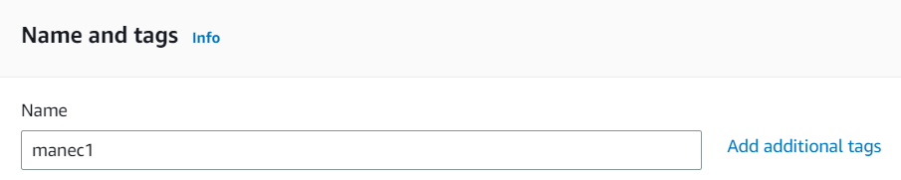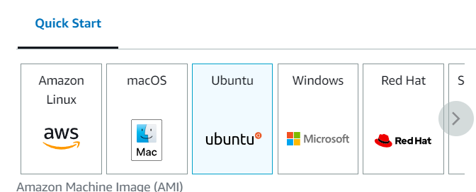

1. In “key pair” section click on “create new key pair” and give a key pair name which is not used before (ex-key100) and click on click key pair.

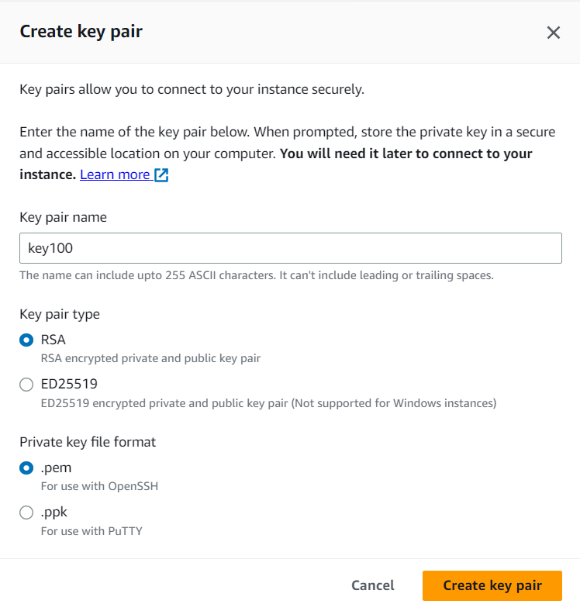

1. Check allow SSH,HTTPS,HTTP and then click on launch instance and ec2 server is created .

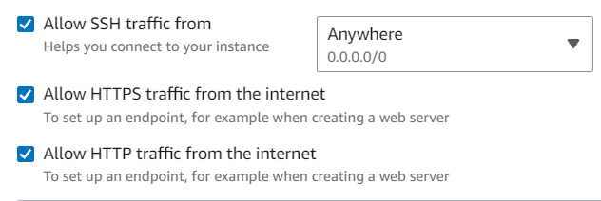

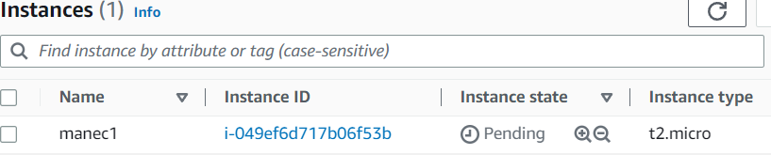

1. Click on instance id and copy “Public IPv4 address” .
2. Open Bitvise SSH client and copied IPv4 address is pasted on “Host” section and in Authentication section in Username give Ubuntu and in initial method select public key.
3. Now click on client key manager and import that downloaded .pem file(ex-key100.pem). and now in client key select global1 if the location name is **Global1.**
4. Click on login and accept and save .

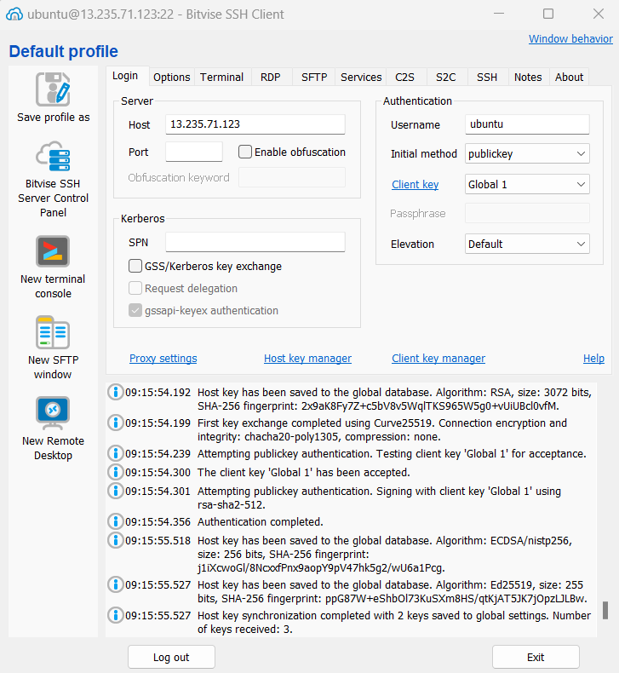

1. Now,click on “New Terminal Console” and write these commands-
   1. **sudo apt-get update**
   2. **sudo apt-get upgrade**
   3. **sudo apt-get install nginx**
   4. **curl -sL https://deb.nodesource.com/setup_16.x|sudo -E bash –**

(curl: a command-line tool used to transfer data from or to a server.

-sL: two options for the curl command. -s is used to silence any progress or error messages, and -L tells curl to follow redirects if any.

https://deb.nodesource.com/setup_16.x: the URL of the script that adds the Node.js package source.

|: a pipe character, which redirects the output of the curl command to the input of the next command.

sudo -E bash -: runs the script with elevated privileges using the sudo command. The -E option preserves the environment variables, and the - option tells bash to read commands from standard input.)

* 1. **sudo apt install nodejs**(server side scripting runtime environment.It allows developers to run JavaScript code outside of a web browser, making it useful for server-side applications and command-line tools)
  2. **git clone https://github.com/hsm2003/repo3.git** (repository name)

after giving repo name, username and password will come .for username we have to give email of github acct and for password we have to give that token(ex-token2).

Then we can see that repo is copied and by typing **ls** we can see that repo- **repo2**

* 1. **cd repo2**

by giving this command we can move to this directory.

* 1. **npm install**

by giving this command in repo2 we have to install npm. npm stands for Node Package Manager. It is a package manager for the Node.js runtime environment, and it is used to install, manage, and share packages or modules of JavaScript code that can be used in Node.js projects.

Now, before starting the server we have to add port number as in index.js file the port is 4000.so we need to add that.

**Steps:-**

1. Go to instances and click instance id (which is used here) and go to security and click security groups.

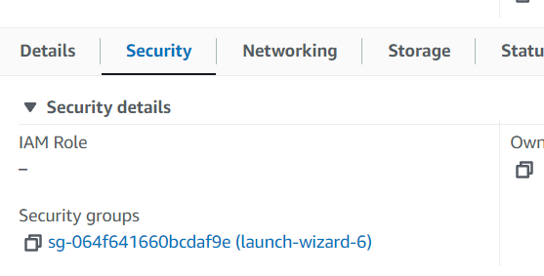

1. In security groups click **Edit inbound rules.**

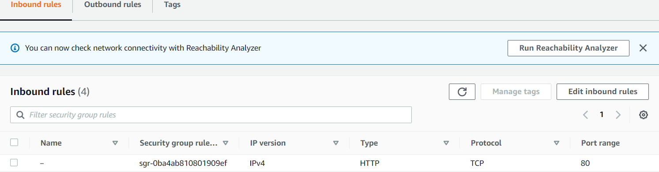

1. In edit inbound rules click **add rule** and in **type** select custom TCP ,in**port range** give 4000 and in **Source** select Anywhere public IPv4.

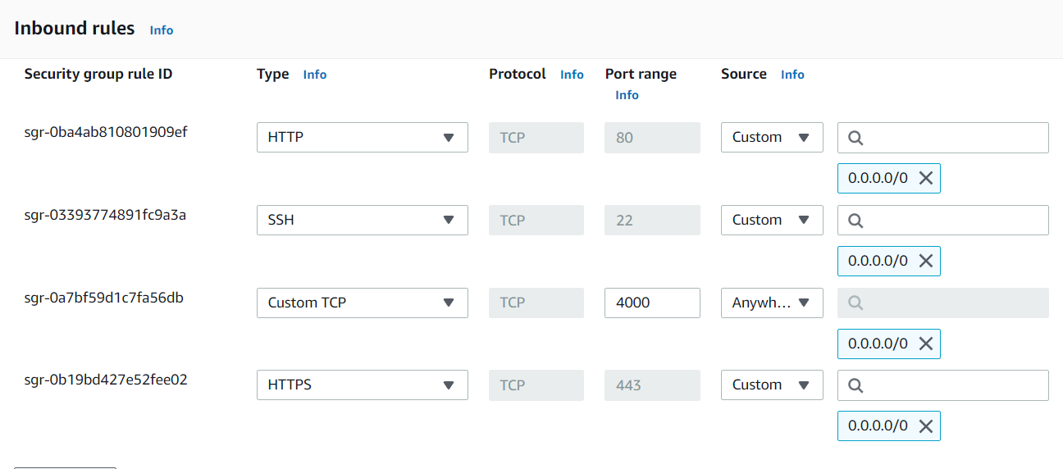

1. Now in bitvise terminal type node index.js and the server is started.

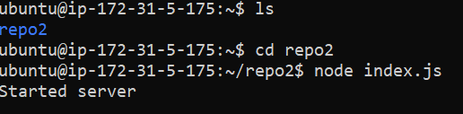

Now, copy that ec2 IPv4 address and paste it in a new tab with **: 4000** and by clicking we can run the website.

